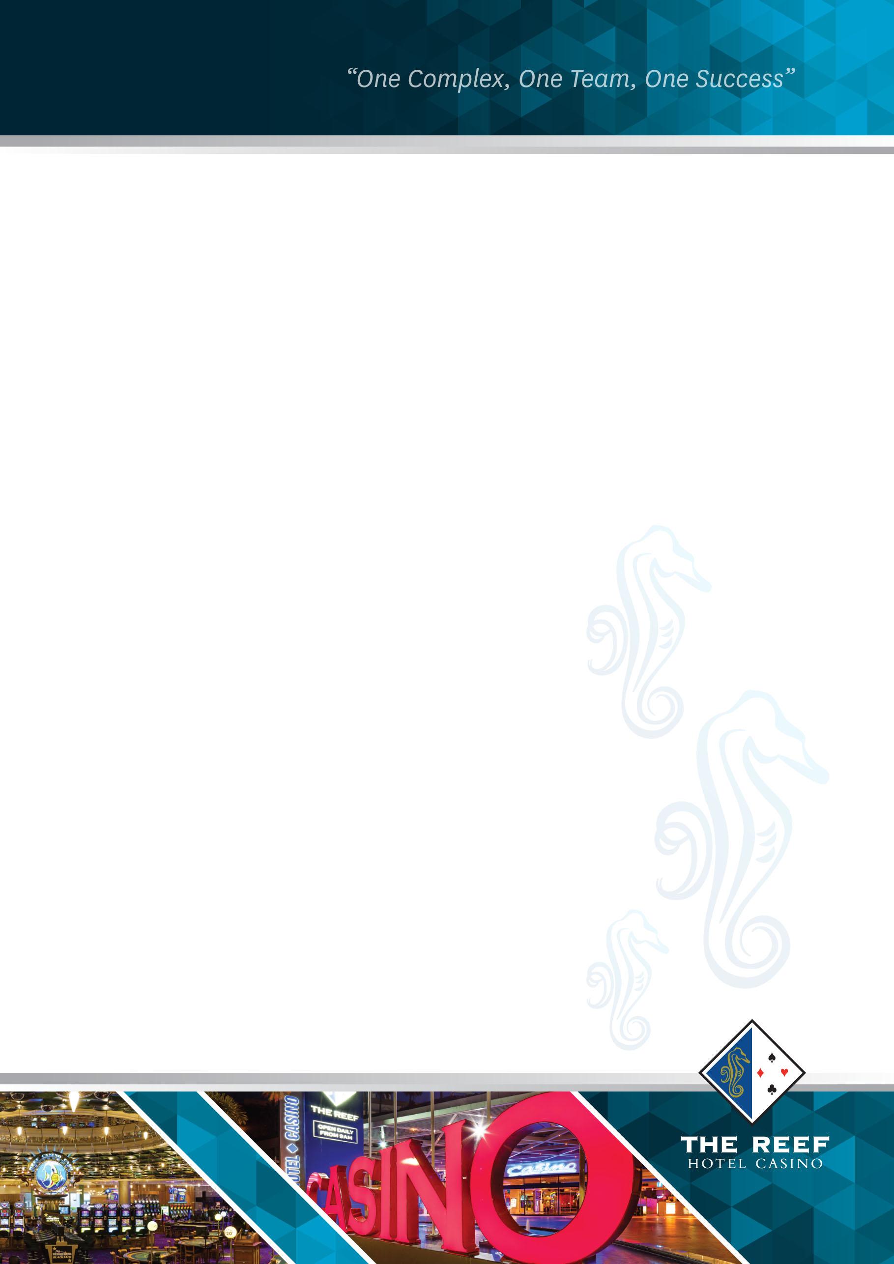

The Reef Hotel Casino

TITLE: Grooming Policy

CATEGORY: Human Resources

SUB CATEGORY: General

EFFECTIVE DATE: August 2022

REVIEW DATE: August 2023

POLICY OVERVIEW
The Reef Hotel Casino is committed to ensuring all employees portray a professional image at all times by maintaining the highest personal grooming standards. All staff members are required to comply with the following policy standards; any exceptions must be approved by a member of the Executive Leadership Team.

Uniforms and Business Attire
The specified uniform must always be worn in full, reflect a professional image, be clean, neatly pressed with no visible flaws.

Non-uniformed employee’s business attire must be conservatively styled and coloured, be worn with discretion and reflect a professional image. Clothing not considered consistent with this image are;
- Denim
- Plunging necklines
- Transparent blouses
- Mini / short skirts
- Body hugging clothing

All clothing must always be fitted appropriately.

Identification / Name Badges
All casino licensed employees are to wear their staff photo identification (ID) and if applicable a name badge (selected departments only) at all times whilst on duty.

All non-casino licensed employees are not required to wear their staff photo identification (ID) but must have it on them at all times. Non-casino licensed employees are required to wear their departments applicable name badge at all times whilst on duty.

ID’s & Name badges are to be worn on the left-hand side, one third of the way down the uniform on the pocket or in a visible position on business attire.

Hands & Nails
Hands and nails must be kept clean and well manicured. Where nail polish is worn, it must be a subtle single colour and not be chipped. French polish is also permitted to be worn. Employees working within the food and beverage department are not permitted to wear nail polish, including French polish, and/or false (acrylic or gel) finger nails.

Jewellery
- Two rings per hand is acceptable, a wedding ring set is permitted. Bulky rings are not permitted unless approved by management.
- Watches are to be of conservative style, no bright colours, and not too large.
- Badges other than approved name badges or pins are not permitted.
- A small stud or sleeper in each ear (All earrings are to be located in bottom lobe section only). No spacers permitted.
- Visible body piercings such as face, eyebrow, tongue, and lip piercings are not permitted.
- One small discrete flat back stud or diamond nose piercing is permitted.
- Any visible jewellery needs to be conservative, not too large or bright in design. One bracelet may be worn. A neck chain worn by uniformed employees must be concealed.

Hair
Hair is to be clean, neat, cut, coloured and styled conservatively. If hair reaches the shoulders or is longer, it must be tied back from the face or worn up in a conservative style, without hair falling out. Plain bobby pins are allowed. Ponytails are to be secured at, or slightly above the nape of the neck.

Facial hair
Beards and moustaches are permitted only if they are neatly trimmed, hygienically clean and of a professional appearance. Side burns must not extend past the middle of the ear and must be conservatively shaped. Any moustache must be above the lip line. Beards and moustaches must be grown during a period of leave unless prior authorisation by management has been given.

Makeup and Fragrance
Makeup must be subtle, no bright or bold colours are permitted. Fragrances and aftershave / cologne must be subtle and not overpowering.

Personal Hygiene
Maintaining good personal hygiene is essential.
- Always wash your hands with soap after going to the toilet, using a nasal tissue, eating, smoking, applying makeup or brushing your hair.
- Shower everyday; you are responsible for maintaining your cleanliness and ensuring there is no body odour.
- Always use a good deodorant that is both an anti-perspirant and deodorant.
- Always change your shirt/blouse/apron daily. If you work long shifts or are involved in physical work, keep a second item in your locker to change through the day.
- Check your breath, brush your teeth regularly and ensure your breath is fresh.
- Smokers need to be particularly careful to ensure that smoke cannot be smelt on breath. Mints may be of assistance but must not be consumed in front of house areas.
- Chewing gum is not permitted.
- In addition, Food & Beverage staff must follow industry guidelines on hygiene and food handling.

Tattoos
In keeping with the company’s professional image, tattoos are not permitted to be directly exposed or visible on the face and/or any areas of the skull whilst on shift. Exposed tattoos must not be offensive, threatening and/or discriminatory. Tattoos that display images or words that depict violence, sexually explicit images or words and/or nudity are generally viewed as being offensive.

If for proven cultural or religious reasons, or for other recognised reasons for a tattoo/ tattoos to be directly exposed or visible on the face and/or any area of the skull whilst on shift, prior approval must be granted to the employees by their relevant General Manager and/or Executive Leadership Team (ELT) member.

Posture
Be conscious of your posture by standing upright with your head up. Slouching, leaning, standing with your arms crossed, arms folded or your hands in your pockets is not acceptable.

Hosiery and Shoes / Footwear
If required, hosiery should be neutral or black and coordinate with, or match the uniform or attire worn. Patterned hosiery not allowed.

Shoes / footwear must have slip resistance soles, be conservatively styled and be kept polished / clean at all times.

Uniformed employees closed in shoes and socks must reflect the colour / style & image of the uniform worn. Shoes and socks must have no patter / design. Safety shoes to be worn for designated positions / roles.

Non-uniformed employees’ shoes / footwear and socks must reflect the colour / style & image of the business attire worn. Open toed shoes / footwear may be worn when appropriate to the work environment. Heals must not exceed 8 cm. Kitchen employees are to wear either black enclosed shoes or safety boots. Kitchen clogs are permitted to be worn by Chefs only.

